# Instructions (GURAS Extract)

## Overview

The ‘GURAS Extract’ Python script will take a csv file input of lot references (ptlotsecpn) and generate an excel file with 2 resulting data sets. The first data set contains the input lot references and the relating ‘propid’s, the second data set will contain the GURAS address data based on the first result’s ‘propids’. If the User selects the ‘Table and csv’ mode, a copy of the data will be inserted into the ‘GURAS_lot’ and ‘GURAS_Data’ tables.

|  |  |  |
| --- | --- | --- |
| Input | Filename | lots_to_guras.csv |
| Data format | *(Heading)*  Plan Type/Lot Number/Section Number/Plan Number  …  **Example:**  ptlotsecpn  DP/1/3/123456  DP/1//123456  SP/1//1234  … |
| Output | Output filename | gurasResults_*%USERNAME%.*xlsx |
| Data tables | mtran.guras_lot  mtran.guras_data |

## How to Run

1. Navigate to the ‘GURAS Extract’ folder: ‘G:\Strategy\GPR\10. Support Applications & Tools\Python\GURAS Extract’
2. Insert the lot references to file ‘lots_to_guras.csv’, save and close the file. (Ensure the lot references are in the correct format, refer to the table above for details)

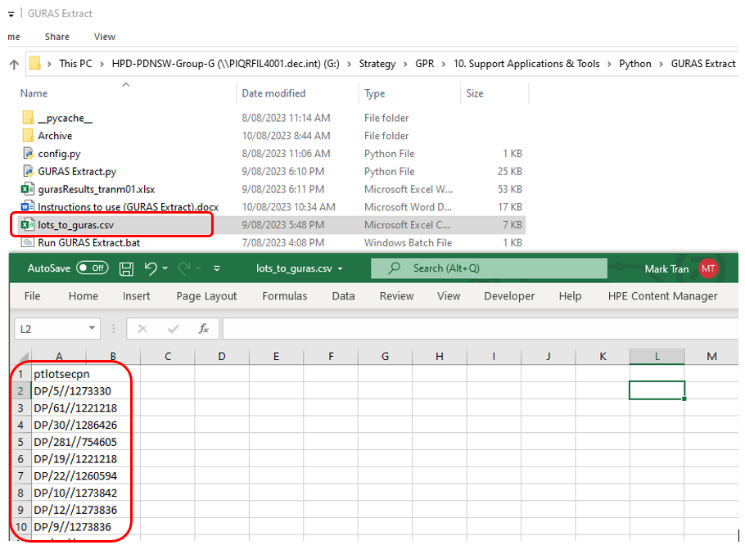

1. Double click on ‘Run GURAS Extract.bat’ to start the process

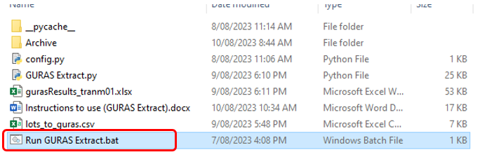

1. Before the process begins, the User will be prompted to choose whether they wish to insert the results into the database or export the results to csv only.

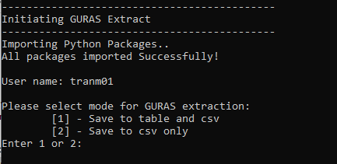

1. Once process has been complete, the results will be saved to a csv file in the same directory. The file name will contain the ‘User name’ of the User that started the process. (gurasResults_*%USERNAME%.*xlsx). If the User chose mode ‘1’, the results will also be inserted into the database along with the User name and Current timestamp.